A Minor Project-I Proposal on

**Pahichaan**

Submitted in partial fulfillment of the requirements for the degree of

Bachelor of Engineering in Software Engineering at Pokhara University

### *By*

**ARJUN PRASAD ADHIKARI**

**SAMIR POUDEL**

**SUNIL GAUTAM**



**Department of Research and Development**

**GANDAKI COLLEGE OF ENGINEERING AND SCIENCE**

Lamachaur, Kaski, Nepal

**(July, 2019)**

A Minor Project Proposal on

**Pahichaan**

Submitted in partial fulfillment of the requirements for the degree of

Bachelor of Engineering in Software Engineering at Pokhara University

### *By*

**ARJUN PRASAD ADHIKARI**

**SAMIR POUDEL**

**SUNIL GAUTAM**

***Supervisor***

**Er. NISHAL GURUNG**



**Department of Research and Development**

**GANDAKI COLLEGE OF ENGINEERING AND SCIENCE**

Lamachaur, Kaski, Nepal

**(July, 2019)**

**APPROVAL CERTIFICATE**

This project entitled "Record Book" prepared and submitted by "Arjun Prasad Adhikari, Samir Poudel and Sunil Gautam" under the supervision of "Er. Nishal Gurung" in partial fulfillment of the requirements for the Degree of Bachelor of Engineering in Software Engineering has been examined and is recommended for approval and acceptance.

**Date of Evaluation:** 4th July, 2019

**……………………**

**Er. Nishal Gurung**

(Project Supervisor)

**…………………**

**Er. Sujan Tamrakar**

(Project Head)

**Research and Development**

**Gandaki College of Engineering and Science**

**…………………**

**Mr. Ashok Raj Parajuli**

(Vice Principal)

**Gandaki College of Engineering and Science**

**ABSTRACT**

*Pahichaan* is a web application which allows the user to connect with each other. It provides a user-friendly platform for users to post their recognition status. Users are allowed to post the pictures of their honors, awards, certificates and text status. Not limited to this, they can connect to each other and react on connection’s post and perform texting to connections.

Similarly, connections will get notified of each other’s activity.

TABLE OF CONTENTS

Chapter 1 1

INTRODUCTION 1

1.1 BACKGROUND 1

1.2 PROBLEM STATEMENT 1

1.3 OBJECTIVES 2

1.4 IMPLICATIONS 2

Chapter 2 3

LITERATURE REVIEW 3

Chapter 3 4

TOOLS AND METHODOLOGY 4

3.1 REQUIRED TOOLS 4

3.2 APPROACH USED 5

3.2.1 USE CASE DIAGRAM 6

3.2.2 ENTITY RELATIONSHIP DIAGRAM (ERD) 7

3.2.3 SYSTEM SEQUENCE DIAGRAM (SSD) 9

Chapter 4 10

TIMELINE CHART 10

Bibliography 11

# LIST OF FIGURES

Figure 2.1: Comparision Diagram 3

Figure 3.2.1: Use Case Diagram 6

Figure 3.2.2: Entity Relationship Diagram 8

Figure 3.2.3: System Sequence Diagram 9

Figure 4.1: Gantt Chart 10

# LIST OF TABLES

Table 3.1: Tools and their corresponding usage 4

# Chapter 1

# INTRODUCTION

## 1.1 BACKGROUND

Human beings have a natural tendency to express. They want to share how they feel, what they want to do and most obviously, what they have achieved in life. Social media plays an important role in our life as it provides a platform to express and get connected with the one with similar sets of interests. Unlike the old days, they provide the users a global exposure. Apart from that, it helps to build a good professional network.

A good profile on a social site has its own perks. Forbes (2018) mentions that information found on social media can set job candidates apart in a positive way. Some believe that a lack of online presence could indicate that a candidate has something to hide, or that they fail to keep up with technology and business trends.

## 1.2 PROBLEM STATEMENT

## There are a lot of social networking sites. However, most of them don’t focus on a specific domain and thus, may fail to provide what the user intends to look for. Pahichaan focuses on framing the identity of a person based on their achievements, accomplishments and honors allowing the users with similar interests and goals to be connected with each other. **1.3 OBJECTIVES**

The aim and objectives of this project are to provide an innovative social platform which enables individuals:

* To communicate with the connections via text messaging.
* To notify the users if events like reaction on posts, new connections as well as suspension and deletion of accounts for inappropriate behavior on the network.
* To share images of honors, achievements, and certificates as personal portfolio allowing the users to showcase their recognition.

## 1.4 IMPLICATIONS

The traditional method of exposing own recognition status was a bit tedious and couldn’t get broad recognition in a short period of time. Our very project is the solution to this problem. *Pahichaan* helps in building relationships and communicating with potential connections.  Our web-application will provide the platform to connect people of similar thoughts and react to their posts.

# Chapter 2

# LITERATURE REVIEW

There are a lot of social networking sites. The figure below helps to compare some of the popular ones with *Pahichaan* based on their common and unique features.

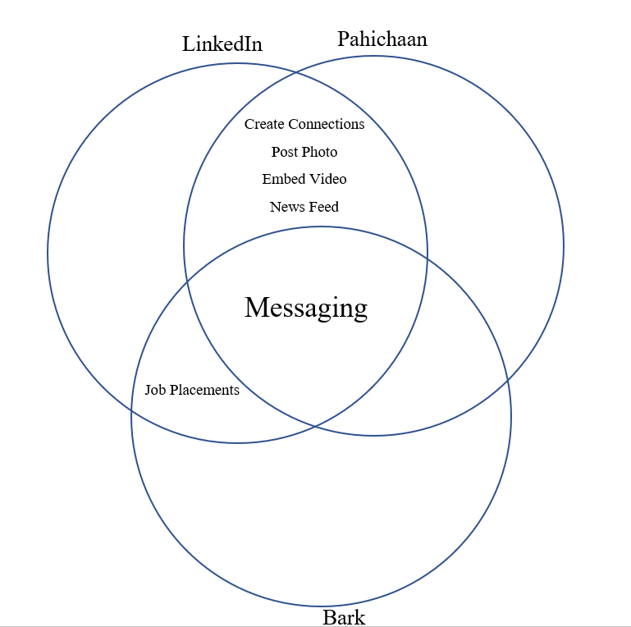

Figure 2.1: Comparison Diagram

# Chapter 3

# TOOLS AND METHODOLOGY

## 3.1 REQUIRED TOOLS

For the development of this project, we require the following tools:

|  |  |
| --- | --- |
| **Tools** | **Usage** |
| Sublime Text Editor | Basic code editing |
| XAMPP Server | Local server and Database |
| Adobe Photoshop | Generating Assets |
| Google Docs, MS Word | Preparing Report |
| Lucid Chart | UML Diagrams |
| MS-Excel | Gantt Chart |
| MS-Powerpoint | Presentation Slides |
| Adobe XD | Prototyping |
| Git | Version Controlling |
| PHP, MySQL, JavaScript, CSS and HTML | Programming |

Table 3.1: Tools and their corresponding usage

## 3.2 APPROACH USED

For our project, we will be using the iterative model of software development. The whole project will be divided into different components. The higher risk components will be developed in earlier iterations. And earlier developed prototypes will be used as a baseline for the next iterations

### 3.2.1 USE CASE DIAGRAM

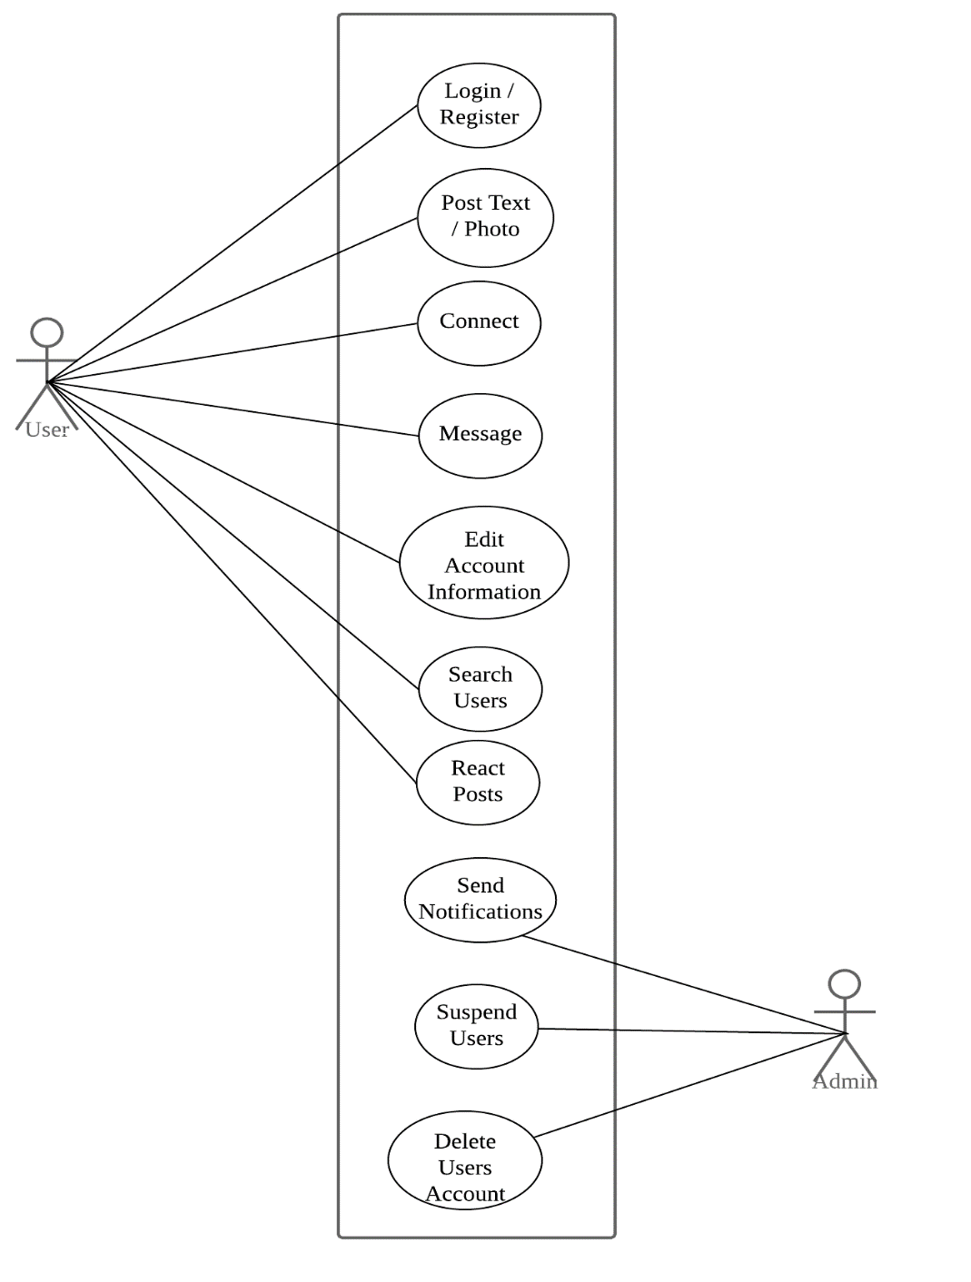The overall process of our system can be easily depicted in the use case diagram below.

Figure 3.2.1: Use Case Diagram

### 3.2.2 ENTITY RELATIONSHIP DIAGRAM (ERD)

The ER diagram below shows the relationship among the various entities of our proposed system. Users can post images and text status, make connections, react on posts and communicate with each other via text message.

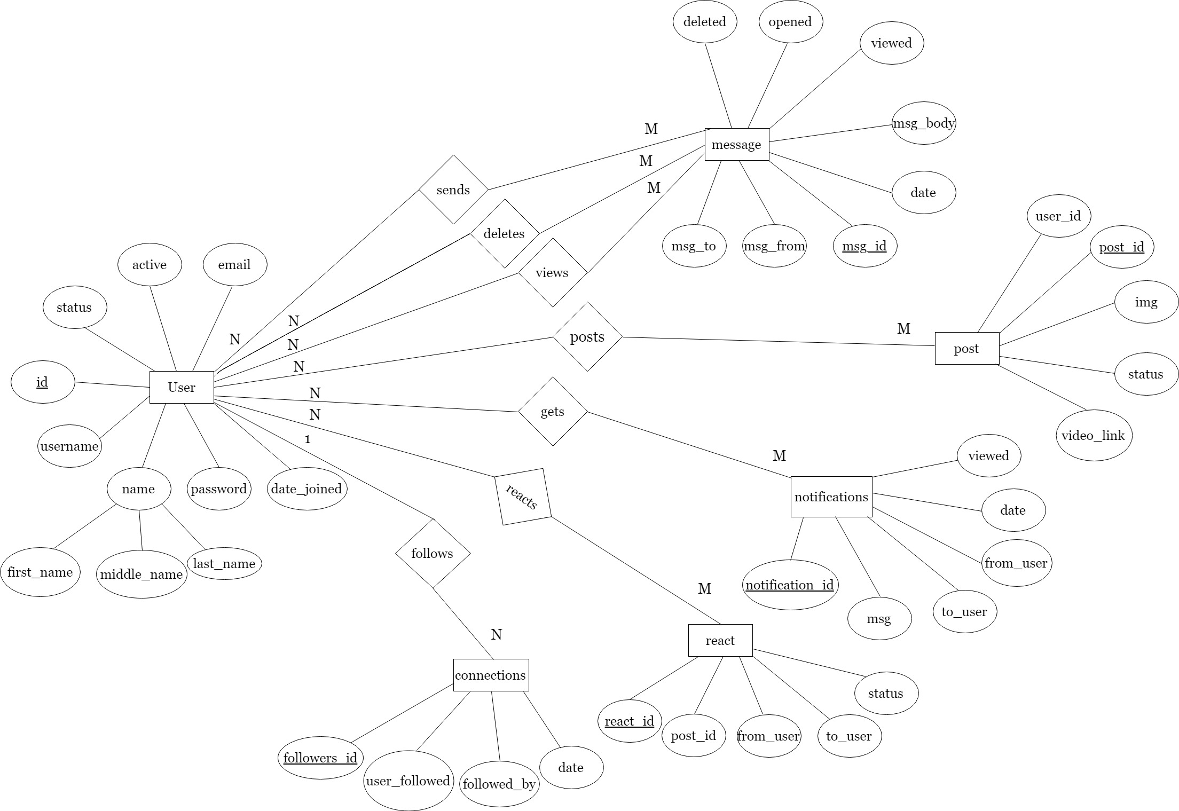

Figure 3.2.2: Entity Relationship Diagram

## 3.2.3 SYSTEM SEQUENCE DIAGRAM (SSD)

Below is a visual summary of interaction between the system and the user

in the form of system sequence diagram.

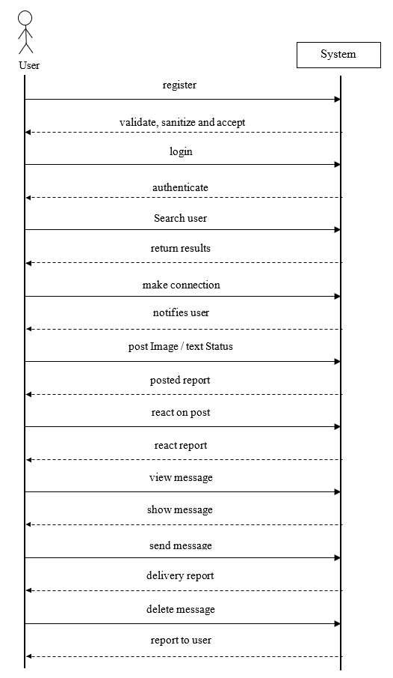

Figure 3.2.3: System Sequence Diagram

# Chapter 4

# TIMELINE CHART

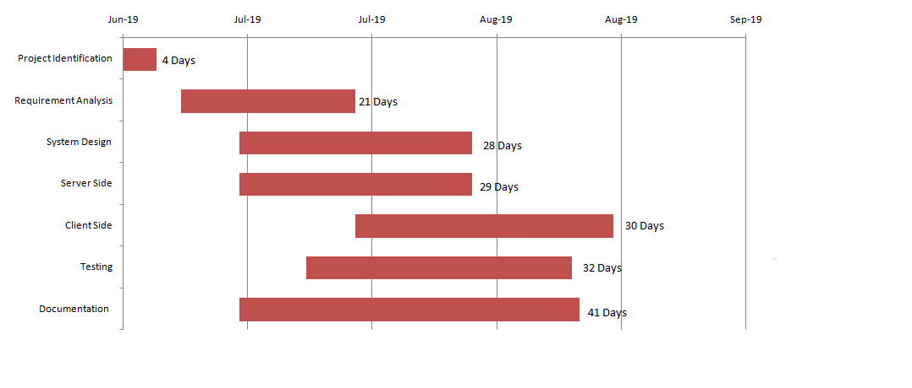

Figure 4.1: Gantt Chart

The above chart demonstrates the work plan of our project.

# Bibliography

Retrieved July 2, 2019, from Forbes: *https://www.forbes.com/#10794fd22254*

Retrieved 2019, from LinkedIn: *https://np.linkedin.com/*

Retrieved July 2, 2019, from Bark: *https://www.bark.com/en/gb/*

Chaffey, D. (n.d.). Retrieved July 2, 2019, from Smart Insights: *https://www.smartinsights.com/social-media-marketing/social-media-strategy/new-global-social-media-research/*